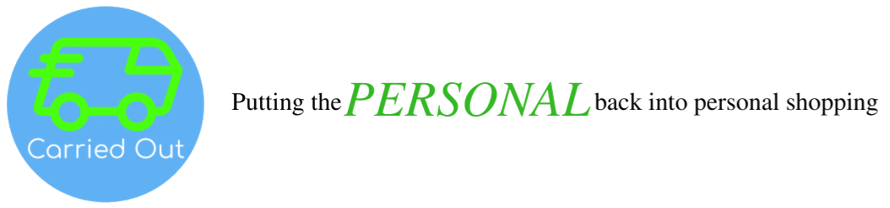
Customer Information Collection, Privacy and Retention Policy (7-20-2020)

- What information will we collect from you?

- Hopefully not much. This is what will need from you:

- Information to complete your Customer Fulfilment Profile (click here).
- Credit Card information (Entered into your Customer Fulfilment Profile)
- Information necessary to fulfil your order such as, but not limited to, a grocery list or where to deliver a gift (may vary from order to order)
- Purchase receipts (a copy will be sent to us by your personal shopper when your order is delivered)

- What personal Information will we share with third parties?

- We will share your name, address and cell phone number with the assigned Personal Shopper for the purpose of fulfilling your order. Your Personal Shopper has pledged to maintain the confidential of such information except as necessary to fulfil your order.

- We will share with your credit card company any information required to process a credit card transaction with them. Your credit card information is never shared with your Personal Shopper.

- We may share non-identifiable customer information with third parties for marketing purposes.

- What personal information will we not share with third parties?

- Very simple. We will not share any of your personal information without your permission except as set forth above or otherwise required to effectively (i) enforce our rights set forth in the Customer Agreement including mediation, arbitration and litigation and (ii) defend Carried Out in any tax or regulatory audits or enforcement proceedings.

- How long will we retain any personal information?

- You may delete you’re your Account and Customer Fulfilment Profile at any time (request is processed within 24 hours).

- We will retain your credit card information until you delete your Account and Customer Fulfilment Profile.

- We may indefinitely retain copies of purchase receipts in our files for accounting, regulatory and marketing purposes.

Page 1 of 2
Page 2 of 2

- We may amend our Customer Information Collection and Retention Policy from time to time. However, if we do, we will inform you of the amended or additional provisions and give you at least 10 days advance notice. If you do not request us to delete your Customer Fulfilment Profile within such time frame, the revised policy will be applied to all of your information currently on file with us and any new information you submit to us after such date.

